**\*/ Roll no: 3005**

**Program name: write a program using if statement /\***

**Code**:

using System;

class ifdemo

{

static void Main(String [] args)

{

int n;

Console.WriteLine("Enter number");

n=Convert.ToInt32(Console.ReadLine());

if(n<10)

Console.WriteLine("The no is less than 10");

}

}

OUTPUT-

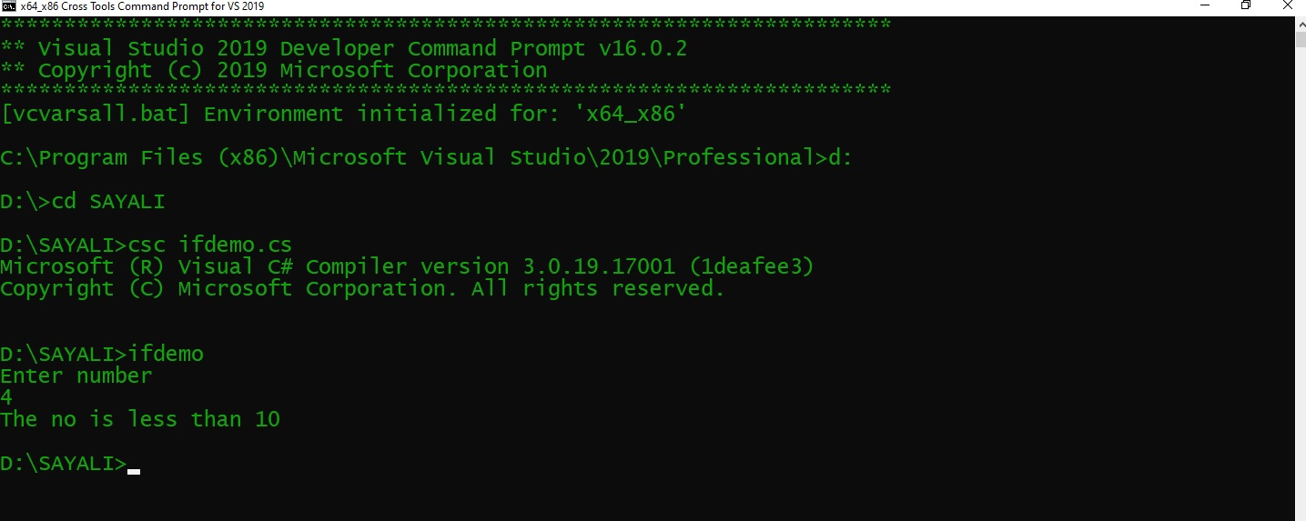

**\*/ Roll no: 3005**

**Program name: : write a program using ifelse statement./\***

**Code**:

using System;

class ifelsedemo

{

static void Main(String [] args)

{

int n,r;

Console.WriteLine("Enter number");

n=Convert.ToInt32(Console.ReadLine());

r=n%2;

if(n ==2)

{

Console.WriteLine("The number is even");

}

else

{

Console.WriteLine("The number is odd");

}

}

}

OUTPUT-

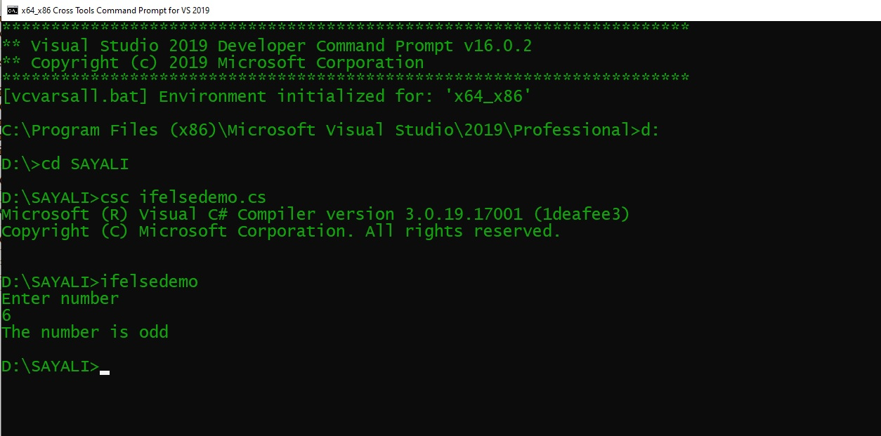

**\*/ Roll no: 3005**

**Program name: : write a program using nested if statement/\***

**Code**:

using System;

class nestedif

{

static void Main(String [] args)

{

int m1,m2,m3,per;

Console.WriteLine("Enter marks");

m1=Convert.ToInt32(Console.ReadLine());

m2=Convert.ToInt32(Console.ReadLine());

m3=Convert.ToInt32(Console.ReadLine());

per=(m1+m2+m3)*100/300;

if(per>=70)

Console.WriteLine("A");

else if((per>=60)&&(per<=70))

{

Console.WriteLine("B");

}

else if((per>=50)&&(per<=60))

{

Console.WriteLine("C");

}

else if((per>=40)&&(per<=50))

{

Console.WriteLine("Pass");

}

else

{

Console.WriteLine("Fail");

}

}

}

OUTPUT-

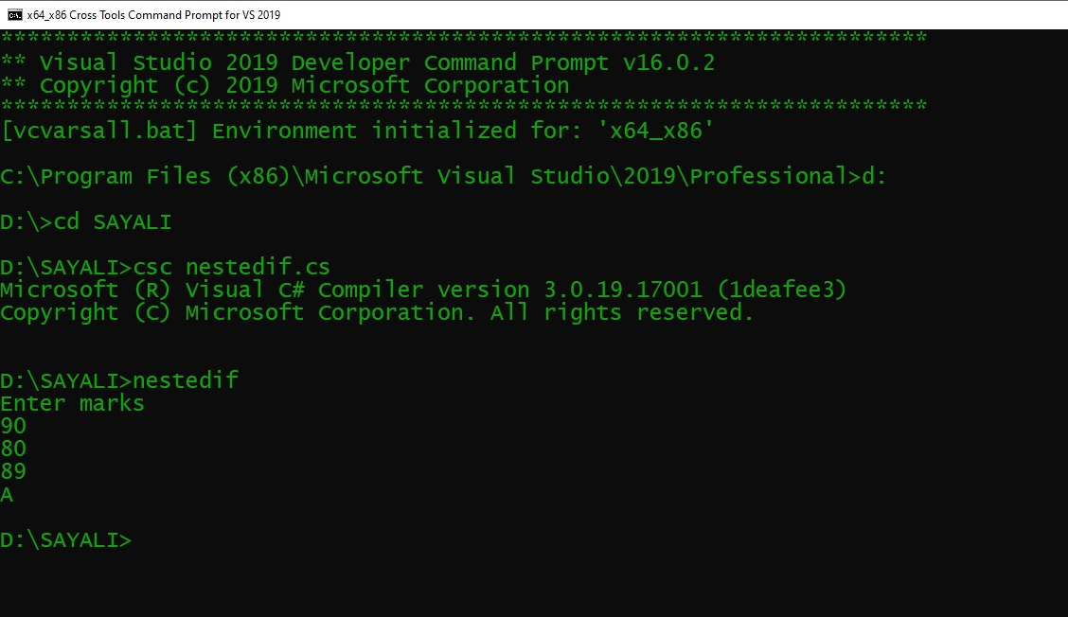

**\*/Roll no: 3007**

**Program name: write a program to enter any character & frame it is capital letter, small letter, digit or special symbol. /\***

**Code**

using System;

class character

{

static void Main(String [] args)

{

char ch;

int a;

Console.WriteLine("Enter any character");

ch=Convert.ToChar(Console.ReadLine());

a=(int)ch;

if((a>=65)&&(a<=90))

{

Console.WriteLine("Entered character is in capital letter");

}

else if((a>=97)&&(a<=122))

{

Console.WriteLine("Entered character is in low letter");

}

else if((a>=48)&&(a<=57))

{

Console.WriteLine("Entered character is in digit");

}

else

{

Console.WriteLine("Entered character is in special symbol");

}

}

}

**OUTPUT-**

D:\SAYALI>csc character.cs

Microsoft (R) Visual C# Compiler version 3.0.19.17001 (1deafee3)

Copyright (C) Microsoft Corporation. All rights reserved.

D:\SAYALI>character

Enter any character

S

Entered character is in capital letter

D:\SAYALI>character

Enter any character

s

Entered character is in low letter

D:\SAYALI>character

Enter any character

1

Entered character is in digit

D:\SAYALI>character

Enter any character

*

Entered character is in special symbol

D:\SAYALI>

**\*/Roll no: 3005**

**Program name: write a program using else ladder./\***

**Code-**

using System;

class Statement

{

public static void Main(string[] args)

{

int number = 12;

if (number < 5)

{

Console.WriteLine("{0} is less than 5", number);

}

else if (number > 5)

{

Console.WriteLine("{0} is greater than 5", number);

}

else

{

Console.WriteLine("{0} is equal to 5");

}

}

}

**OUTPUT-**

D:\SAYALI>csc Statement.cs

Microsoft (R) Visual C# Compiler version 3.0.19.17001 (1deafee3)

Copyright (C) Microsoft Corporation. All rights reserved.

D:\SAYALI>Statement

12 is greater than 5

D:\SAYALI>

**\*/ Roll no: 3005**

**Program name: write a program for factorial./\***

**Code:**

using System;

{

class factorial

{

static void Main()

{

int fact=1,no,i;

Console.WriteLine("enter number");

no=Convert.ToInt32(Console.ReadLine());

for(i=1;i<=no;i++)

{

fact=fact*i;

}

Console.WriteLine("factorial={0}",fact);

}

}

**OUTPUT-**

D:\SAYALI>csc factorial.cs

Microsoft (R) Visual C# Compiler version 3.0.19.17001 (1deafee3)

Copyright (C) Microsoft Corporation. All rights reserved.

D:\SAYALI>factorial

enter number

8

factorial=40320

D:\SAYALI>

**/*Roll no: 3005**

**Program name: write a program to input number & print sum of digit using while loop.*/**

**Code:**

using System;

class sum1

{

static void Main()

{

int s = 0, n, r = 0;

Console.Write("Enter a number :");

n = Convert.ToInt32(Console.ReadLine());

while (n > 0)

{

r = n % 10;

s = s + r;

n = n / 10;

}

Console.WriteLine("Sum of digit=" + s);

}

}

**OUTPUT-**

D:\SAYALI>csc sum1.cs

Microsoft (R) Visual C# Compiler version 3.0.19.17001 (1deafee3)

Copyright (C) Microsoft Corporation. All rights reserved.

D:\SAYALI>sum1

Enter a number :124

Sum of digit=7

D:\SAYALI>

**\*/Roll no: 3005**

**Program name: write a program to print fibonci seres using do while loop./\***

**CODE-**

using System;

class fiboni

{

static void Main(String [] args)

{

int f0=0,f1=1,f2;

System.Console.WriteLine("{0}",f0);

System.Console.WriteLine("{0}",f1);

do

{

f2=f0+f1;

f0=f1;

f1=f2;

System.Console.WriteLine("{0}",f2);

}while(f2<=10);

}

}

**OUTPUT-**

D:\SAYALI>csc fiboni.cs

Microsoft (R) Visual C# Compiler version 3.0.19.17001 (1deafee3)

Copyright (C) Microsoft Corporation. All rights reserved.

D:\SAYALI>fiboni

0

1

1

2

3

5

8

13

D:\SAYALI>

*/**Roll no: 3005**

**Program name: write a program to print following pattern./\***

**Code:**

using System;

class patt

{

static void Main(string[] args)

{

int val = 5;

int i, j, k ;

for (i = 1; i <= val; i++)

{

for (j = 1; j <= i; j++)

{

Console.Write("");

}

for (k = 1; k <= i; k++)

{

Console.Write(" *");

}

Console.WriteLine("");

}

Console.ReadLine();

}

}

**OUTPUT-**

D:\SAYALI>csc patt.cs

Microsoft (R) Visual C# Compiler version 3.0.19.17001 (1deafee3)

Copyright (C) Microsoft Corporation. All rights reserved.

D:\SAYALI>patt

*

* *

* * *

* * * *

* * * * *

**\*/Roll no: 3005**

**Program name: write a program using break & continue statement.*/**

**Code:**

using System;

class conti

{

public static void Main()

{

int n = 10;

while (n < 200)

{

if (n < 50)

{

Console.WriteLine(" " + n);

n = n + 10;

continue;

}

if (n == 50)

{

Console.WriteLine();

n = n + 10;

continue;

}

if (n > 90)

break;

Console.WriteLine(" " + n);

n = n + 10;

}

Console.ReadLine();

}

}

**OUTPUT-**

D:\SAYALI>csc conti.cs

Microsoft (R) Visual C# Compiler version 3.0.19.17001 (1deafee3)

Copyright (C) Microsoft Corporation. All rights reserved.

D:\SAYALI>conti

10

20

30

40

60

70

80

90

**\*/Roll no: 3005**

**Program name: write a program for menu using switching odd even, prime or not,**

**Armstrong or not, palindrome or not, exit.*/**

**Code:**

using System;

class driven

{

static void Main(string[] args)

{

Console.Write("\n\n");

Console.WriteLine("MENU\n");

Console.WriteLine("1] Even & Odd");

Console.WriteLine("2] Armstrong Or Not");

Console.WriteLine("3] Palindrome Or Not");

Console.WriteLine("4] Prime Or Not");

Console.WriteLine("5] Exit");

int n = 0;

while (true)

{

Console.Write("\n");

Console.Write("Enter your choice :");

n = Convert.ToInt32(Console.ReadLine());

switch (n)

{

case 1:

{

int num1, rem1;

Console.Write("\n\n");

Console.WriteLine("Check whether a number is even or odd :");

Console.WriteLine("---------------------------------------------------");

Console.Write("Input an integer : ");

num1 = Convert.ToInt32(Console.ReadLine());

rem1 = num1 % 2;

if (rem1 == 0)

Console.WriteLine("\n{0} is an even integer\n", num1);

else

Console.WriteLine("\n{0} is an odd integer\n", num1);

break;

}

case 2:

{

int y, r, s = 0, y1;

Console.Write("\n\n");

Console.WriteLine("Check whether a number is Armstrong or not :");

Console.WriteLine("---------------------------------------------------------");

Console.Write("Input an integer : ");

y = Convert.ToInt32(Console.ReadLine());

y1 = y;

while (y1 != 0)

{

r = y1 % 10;

s = s + r * r * r;

y1 = y1 / 10;

}

if (s == y)

{

Console.WriteLine("\n{0} is armstrong number\n", y);

}

else

{

Console.WriteLine("\n{0} is not a armstrong number\n", y);

}

break;

}

case 3:

{

int x, r, result = 0, x1;

Console.Write("\n\n");

Console.WriteLine("Check whether a number is Palindrome or not :");

Console.WriteLine("----------------------------------------------------------");

Console.Write("Input an integer : ");

x = Convert.ToInt32(Console.ReadLine());

x1 = x;

while (x1 > 0)

{

r = x1 % 10;

result = result * 10 + r;

x1 = x1 / 10;

}

if (x == result)

{

Console.WriteLine("\n{0} is palindrome number\n", x);

}

else

{

Console.WriteLine("\n{0} is not a palindrome number\n", x);

}

break;

}

case 4:

{

int num;

Console.Write("\n\n");

Console.WriteLine("Check whether a number is Prime or not :");

Console.WriteLine("---------------------------------------------------");

Console.Write("Input an integer : ");

num = Convert.ToInt32(Console.ReadLine());

int k;

k = 0;

for (int i = 1; i <= num; i++)

{

if (num % i == 0)

{

k++;

}

}

if (k == 2)

{

Console.WriteLine("\n{0} is prime number\n", num);

}

else

{

Console.WriteLine("\n{0} is not a prime number\n", num);

}

break;

}

case 5:

{

break;

}

default:

Console.WriteLine("\nSorry, invalid selection\n");

break;

}

n++;

if (n <= 5)

continue;

else

break;

}

}

}

**OUTPUT-**

D:\SAYALI>csc driven.cs

Microsoft (R) Visual C# Compiler version 3.0.19.17001 (1deafee3)

Copyright (C) Microsoft Corporation. All rights reserved.

D:\SAYALI>driven

MENU

1] Even & Odd

2] Armstrong Or Not

3] Palindrome Or Not

4] Prime Or Not

5] Exit

Enter your choice :1

Check whether a number is even or odd :

---------------------------------------------------

Input an integer : 1

1 is an odd integer

Enter your choice :2

Check whether a number is Armstrong or not :

---------------------------------------------------------

Input an integer : 24

24 is not a armstrong number

Enter your choice :3

Check whether a number is Palindrome or not :

----------------------------------------------------------

Input an integer : 34

34 is not a palindrome number

Enter your choice :2

Check whether a number is Armstrong or not :

---------------------------------------------------------

Input an integer : 153

153 is armstrong number

Enter your choice :